**Christopher King**

**2018141521058**

**Mechanical Design 2**

**Class Section 01**

**09/26/2021**

# **Problem 1**

The job is to conduct a first-cut shaft diameter estimation. Designed shaft needs to transmit 1000 N-m torque with superimposed 250 N-m alternating torque due to torsional vibration. Shaft material is a heat- treated alloy steel with Sut=1.2GPa and Sy=1.0GPa. The shaft has a shoulder with designated D/d=1.2 and r/d=0.05. Shaft surface demands a good quality ground finish. Reliability target of the designed shaft is 95 percent.

1. What is the minimal diameter required for infinite life?
2. Identify your assumptions made to get estimated diameter.

**Solution:**

1. For this question, we are asked to determine the minimal diameter required for infinite life.

Assume

And

Therefore, the endurance limit is equal to

Next, we consider to modify the endurance limit.

Surface Condition (ground):

Size Effect:

Loading Effect (torsion):

Temperature Effect (room temperature):

Reliability Effect (95%):

Therefore, the modified endurance limit is equal to

From Table A-15-8, I can know that the stress concentration factor for D/d=1.2 and r/d=0.05 round shaft with shoulder fillet is equal to

And because the stress in this question is torsion,

The fatigue stress concentration is equal to

And

For the minimal diameter required for infinite life,

Therefore,

1. For this question, we are asked to identify your assumptions made to get estimated diameter.

Because , the assumption is satisfied.

# **Problem 2**

The rotating solid steel shaft is simply supported by bearings at points B and C and is driven by a gear (not shown) which meshes with the spur gear at D, which has a **150-mm** pitch diameter. The force F from the drive gear acts at a pressure angle of **20°**. The shaft transmits a torque to point A of **TA = 340 N · m**. The shaft is machined from steel with **Sy = 420 MPa** and **Sut = 560 MPa**.

Using a factor of safety of **2.5**, determine the minimum allowable diameter of the 250-mm section of the shaft based on (a) a static yield analysis using the distortion energy theory and (b) a fatigue-failure analysis. Assume sharp fillet radii at the bearing shoulders for estimating stress-concentration factors.

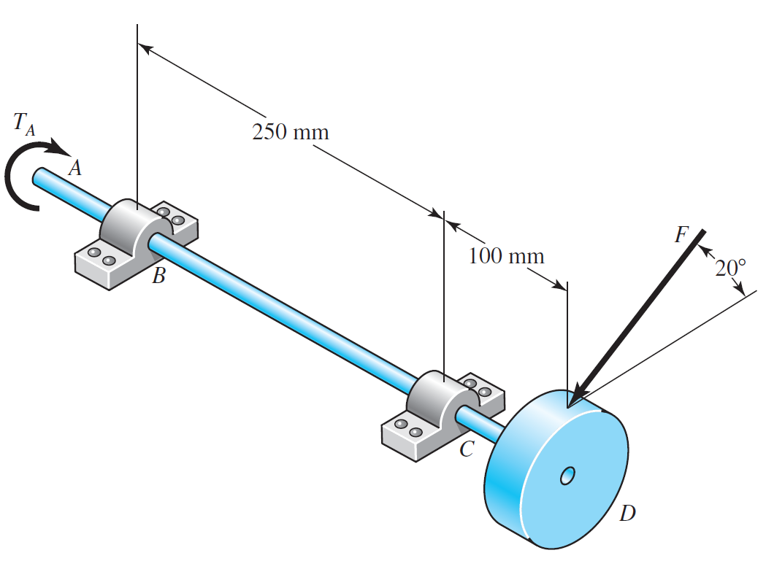

**Solution:**

For this question, we are asked to determine the minimum allowable diameter of the 250-mm section of the shaft based on (a) a static yield analysis using the distortion energy theory and (b) a fatigue-failure analysis. Assume sharp fillet radii at the bearing shoulders for estimating stress-concentration factors.

From the force analysis, I can know that

And the maximum bending moment occurs at point C, which is equal to

Therefore, we can know that at point C:

For sharp fillet, and .

And,

The fatigue stress concentration is equal to

The fatigue stress concentration is equal to

Assume and .

So,



And



Assume

And

Therefore, the endurance limit is equal to

Next, we consider to modify the endurance limit.

Surface Condition (machined):

Size Effect:

Loading Effect (bending):

Temperature Effect (room temperature):

Reliability Effect:

Therefore, the modified endurance limit is equal to

Hence,

# **Problem 3**

The torque to be transmitted through the key from the gear to the shaft is T = 2819 in-lbf. The nominal shaft diameter supporting the gear is 1.00 in. Specify a square key for torque transmission, using a factor of safety of 1.1. Use 1020 CD steel for the key material and DET theory as the failure criteria for safety factor calculation.

**Solution:**

For this question, we are asked to specify a square key for torque transmission, using a factor of safety of 1.1.

From Table 7–6, a -in square key is selected. Choose 1020 CD steel for the key material, with a yield strength of 57 kpsi.

From Fig. 7–19, the force F at the surface of the shaft is

By the distortion-energy theory, the shear strength is

Failure by shear across the area ab will create a stress of . Substituting the strength divided by the design factor for gives

To resist crushing, the area of one-half the face of the key is used:

Failure by crushing the key is the dominant failure mode, so it defines the necessary length of the key to be .